REPUBLIC OF CAMEROON
Peace-work-Fatherland
REPUBLIC DU CAMEROUN

Paix-Travail-Patrie


THE UNIVERSITY OF BAMENDA

UNIVERSITE DE BAMENDA

Box 39 Bambili, CAMEROON
Tel: 237 677686681/67547724 Fax: 237 33 05 10 69, website: www.uniba.cm

THE COLLEGE OF TECHNOLOGY (COLTECH) ECOLE DE TECHNOLOGIE

DEPARTMENT OF COMPUTER ENGINEERING

OPTION: SOFTWARE ENGINEERING.
ACADEMIC INTERNSHIP CARRIED OUT AT SEED BAMENDA
FROM AUGUST 02nd TO SEPTEMBER 02nd
LEVEL 200
ACADEMIC REPORT

PRESENTED BY:
TEAH LEVI TORSWEEN
UBa24PB101

FIELD SUPERVISOR: MBAH LESKY

A
C
A
D
E
M
I
C
Y
E
A
R
:
2
0
2
4
/
2
0
2
5

ACKNOWLEDGEMENT

I will like to begin by expressing my deepest gratitude to God Almighty for giving me the strength,

and wisdom to successfully complete this internship and report.
I am immensely thankful to my parents and specially my father for their great support, love, and encouragement which have been my greatest source of motivation throughout this journey.
A special thanks goes to my supervisor Mr. MBAH LESKY and Mr. KEWANGANG MUHAMMED NURDIN, for their constant guidance, insightful feedback, teachings, and for providing me with the opportunity to learn and grow during my time here. Your mentor-ship has shaped me well in the tech fields.

DEDICATION
To my Parents for their efforts undertaken for me as their child so as to acquire a good professional knowledge and become great personalities tomorrow, I dedicate my work to you as a token of my gratitude and appreciation for your endless support.
I dedicate this report to God Almighty, whose grace and guidance have been my constant source of strength throughout this journey

GENERAL INTRODUCTION 1
1.1 Definition of internship 1
1.2 Purpose of internship 1
1.5 DESCRIPTION OF THE HOST INSTITUTION 2
1.5.1 SITUATION AND PRESENTATION 2
1.5.1 SITE AND INFRASTRUCTURE 2
1.7 ORGANIZATION AND FUNCTIONING 4
1.7.1 ORGANS ORGANIZATIONAL HIERARCHY CHART 4

LIST OF ABBREVIATIONS
- CSS: Cascading Style Sheets
- HTML: HyperText Markup Language
- XAMPP: Cross-Platform, Apache, MySQL, PHP, Perl
- IT: Information Technology
- PHP: Hypertext Prep
- UI/UX: User Interface and User Experience

CHAPTER ONE

GENERAL INTRODUCTION

1.1 Definition of internship
Internship can be defined as a professional learning experience that offers meaningful, practical work related to the student's field of study giving the student the opportunity for career exploration, development and to learn new skills.

1.2 Purpose of internship
_ Internship exposes students to real life practices and types of projects to work on according to their field of interest
- Internships give students the opportunity to have real world experience in the career field they want to pursue.
- Internship gives students the
- It prepares them for what to expect in their field and increases confidence in their work.
- Gives students opportunities build up an entrepreneurial mindset

1.3 Importance of internship
- While classroom learning is important, internships allow students to apply what they learned in a practical setting, helping them prepare for tasks they may complete once they begin their career.
- Help students determine their interest and clear vision on what they want to do.
- Help boost students' confidence.
- Provides professional soft skills needed in a workplace and in leadership positions.
- It helps gain professional feedback.

1.4 Objectives of internship
- To assist interns to expose themselves to various aspects of the business in a systematic and productive manner.
- To train interns with the right values and working attitudes.
- To develop skills and techniques directly applicable to their career.
- To provide students to test their interest in a particular career before permanent commitment is made.

1.5 DESCRIPTION OF THE HOST INSTITUTION

1.5.1 SITUATION AND PRESENTATION

1.5.1 SITE AND INFRASTRUCTURE
N-Tec is located at Foncha Junction Mile III Nkwen Bamenda. It is a site of many other
businesses. Currently, its building is painted red on the front and green on the sides. The office is
on the second floor of the building. Adjacent to the building is Mr Baker.
N-Tec also has a documentation close to the office, but it is located at the opposite site of the
road and closer to the junction

1.5.2 HISTORY AND STATUS
N-TEC started some 21 years ago with the name YUTARR PRODUCTIONS, with the CEO
MR. NGWAYI JOHN NGWANI. The organization was aimed at printing examination questions
papers and providing basic computer software classes, but as with time, new ideas were
developed and there was an introduction of the computer hardware repair and maintenance
department.
At that period N-TEC which was known as YUTARR PRODUCTIONS moved to a new location
since there was a need for space, which was not available in the formal location. The
organization then moved to Foncha junction and this was within the period when internet
connections became a necessity as people started developing interest in communication overseas
to relatives and friends through emails, researching on the internet and many other activities.
With this new innovation the organization then added a new branch called YUTANET with the
main focus of this particular branch being the provision of internet connections to its customers
through a cyber café. As time went on there was greater need for internet connections at people’s
private homes and offices which then brought the idea of changing the branch’s name and designing
a new logo for the place. So great changes were made and YUTARR PRODUCTIONS
was changed to N-TEC, the cyber café’s name was changed to N-TEC RESOURCE CENTER and
the services for providing WIFI(wireless fidelity) connections to homes and offices was
known as N-TEC WIRELESS. It also started training and carrying out computer services such as
web development, mobile application development and graphics designing. The CEO’s son later
moved to Yaounde, where he opened another branch; N-Tec Labs. It now has its website at
nteclabs.com


Fig1; Logo of N-Tec

1.5.3 PARTNERSHIPS
N-Tec is now a government registered institute. It issues certificates on secretaryship, office
automation, web development, mobile application development, computer maintenance, graphics
designing and more. Their certificates are recognized by the government and can also be used in
some other countries.
N-Tec labs at Yaounde also works with them as it is their main office which provide graphics, web
and mobile app services. Epoxy Designs is also one of their partners.
N-TEC also aims at sales of brand-new computers, second-hand computers, desktops and laptops,
hard disk drives of any storage capacity, single monitors and central units (CPU-Central Processing
Units), video cards, sound cards, RAM for both desktops and laptops. Its competitors who also deal
with computers are CODED SOURCE which deals with maintenance of software situated at mile
2 Nkwen, FLEXCOM.

1.6 VISION, MISSION AND OBJECTIVES
1.6.1 VISION
At first, N-Tec provided just printing and teaching services. It later became a cyber cafe which
provided access to the internet. N-Tec’s Vision is to become recognized in countries all over
Africa, where people can use N-Tec issued certificates to get Jobs in the countries all over Africa
and even the world. They also want to create other branches in the country and even expand to
other countries as time goes.
1.6.2 MISSION
N-Tec's Mission is to inspire many more people to come into the field of computer engineering.
Be it Software development, office automation or networking. For we are moving towards a digital
future. It also aims to produce good quality services and products such as software packages and
best teaching practices.
1.6.3 OBJECTIVES
The main objectives of N-Tec are;
● Computer maintenance
● Computer networking
● Sales of computer and its accessories
● Office training
● Web development
● Mobile application development
● Graphics designing
● Computer training

1.7 ORGANIZATION AND FUNCTIONING

1.7.1 ORGANS ORGANIZATIONAL HIERARCHY CHART

MANAGER

ASSISTANT MANAGER

Maintenance Department
Software Department
Networking Department
Microsoft Department

1.7.2 FUNCTIONING
This enterprise is aimed at the literacy of hardware maintenance, electronics repairs and internet
service (cyber café) both wired and wireless. N-Tec is a large enterprise that has to do with the
following:
MICROSOFT: This department permits people of different works of life to acquire skills that will
enable them to create text-based documents of all sort using Microsoft word, carrying tasks
involving calculations such as creating formulae, financial analysis/accounts, graphs, charts,
reports, solve mathematics/statistical problems in a short time using Microsoft excel (or others like
Corel Quattro Pro and Lotus 1-2-3). This department also opportune the use of database programs
(such as MS Access, Corel Paradox, and Lotus Approach) to sort, analyze, track, search, query and
even manage information on a computer. Also presentation programs (such as MS PowerPoint,
Corel Presentations and Lotus Freelance Graphics) can be used to combine a variety of visual
objects to create attractive and interesting presentations. Students are also trained in the usage of
communication programs such as MS Outlook to communicate with friends and relatives as well as obtain information.

NETWORKING: The networking department of N-Tec Resource Center is aimed at creating a
better, sound and effective network for their customers as well as providing them with better
services such as the setting up of a cyber café (to provide fast internet services) and also building a
Local Area Network (LAN). The enterprise is currently trying to set up different branches in other
parts of the town and country which would lead to diversified products and services.
HARDWARE: This is much aimed at the repair/maintenance of hardware devices such as
computers (laptops, desktop, iPods etc.), phones, flat screen televisions, printers, photocopiers,
scanners etc. This department is also specialized in the repair and maintenance of network devices
such as routers, switches, hubs, just to name a few. It is also aimed at educating the general public
and also their customers on how to use these devices.
SOFTWARE: This department where I carried out my internship has good skills of creating and
supplying software for their customers based on their desires. It provides software such as login
pages, building and hosting websites, developing mobile apps for android and iphone, desktop apps
for Windows and Linux for both private and industrial use. It also trains people like interns on how
to create this softwares. This department also produces graphics contents ranging from documents
such as flyers to videos such as adverts.
WIRELESS: The wireless department has developed the enterprise to greater height making them
one of the leading wireless distributors in the North West Region and hoping to expand to in due
course other regions across the country. Their main aim is to provide the general public with internet
at affordable prices (that is to both the rich and the poor) so that we can all belong to an emerging world.

1.7.3 HUMAN RESOURCES
The N-Tec Resource Center is not that big in terms of organizational size but very efficient and
trustworthy in products and services. There are four permanent employees/workers which include
the Manager (MR. NGWAYI DONALD) who doubles as the head of hardware/software
department, the Assistant Manager (MRS. NGWAYI ERNESTINE) who is also the head of
Microsoft department. We also have NGWAYI JOEL TANTOH who is head of the software
departments and also the son of the CEO, for such the N-Tec RC is a family enterprise. There is
also the Secretary who is in charge of the cyber café and there are many temporary workers/
employees and also students learning computers who come and go as the need for them arises.

CHAPTER TWO
INTERNSHIP ACTIVITIES
2.1 Program of activities as elaborated:
The professional training lasted for a months from August 02nd – September 02nd. During this period, version control and mobile app development.
Following the given planning schedule of my visit at SEED, this was to help me have a general view and knowledge of the work done in the enterprise, and the different activities carried out.
I was supervised and followed up by my field supervisor in order to clear out any of my doubts providing answers to any question asked and to see if I was on the move with the tasks and work given properly.
I had the opportunity to work on projects that were assigned to me on Android studio, Git and GitHub, and gave an outcome of the work done.

2.2 DESCRIPTION OF THE ACTIVITIES EFFECTIVELY DONE
activities carried out within our internship period
2.2.1 My personal portfolio:
I learnt how to create personal portfolio. This portfolio contain was built using HTML, CSS,

and JavaScript as my first project at N-tec institute. It is made up of the home page that

contains the general overview of myself, a contact and skills pages which can be navigated to.

code outcome
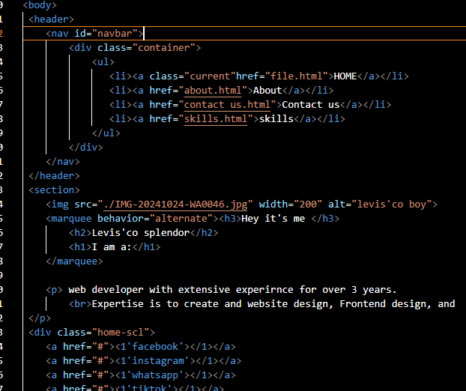
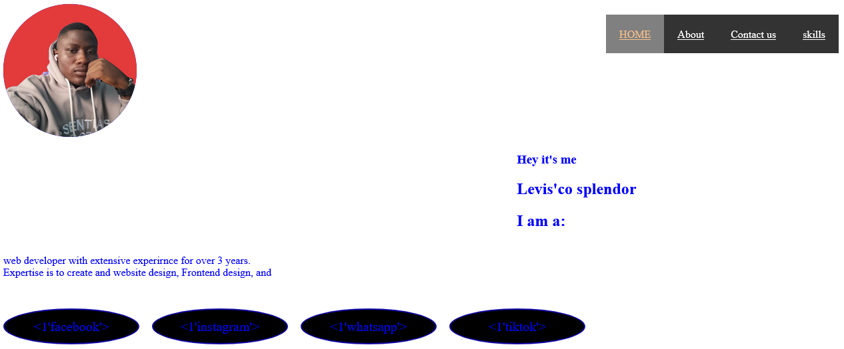

Fig2: portfolio code fig3: portfolio website.

2.2.2 LogIn validation
This was our second project which we assign to work on as personal project
Here, I used programming languages such as HTML, CSS and JavaScript. Where the HTML builds up the login form, the CSS is used to make it look beautiful and the JavaScript for functionality of the form .
The login validation is form that contains forms where the user will fill in the necessary informations for them to login, meaning that if any of this informations are absent, they won’t be able to login.
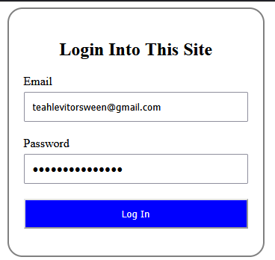
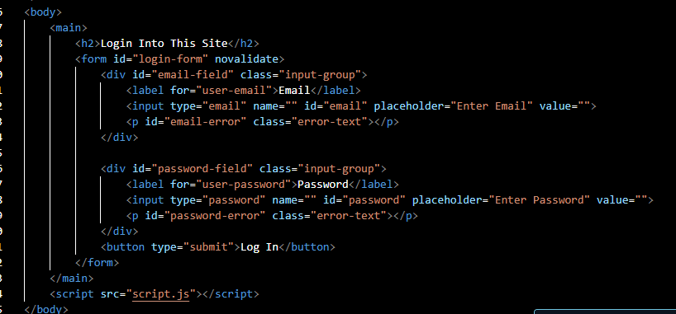
[Cite your source here.]
2.2.3 Password Generator
Our third project was to create a password generating form in groups of four. The main aim was for us to share ideas and come out with something unique. Here we use HTML, for building, CSS for styling, JavaScript for functionality and Microsoft drawing for the flowchat diagram. The project was carried out by dividing the work among us by the group leader.
The password generator for is required to generate a password for the user according to the users input, that is the password may contain uppercase letters, lowercase letters, numbers and special case characters.
Flowchat code
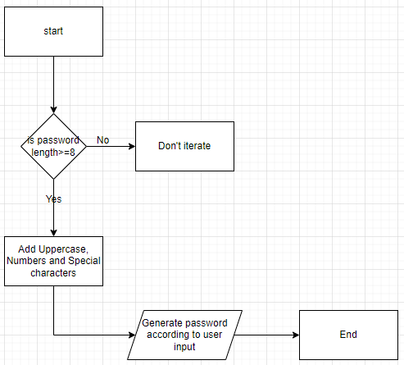
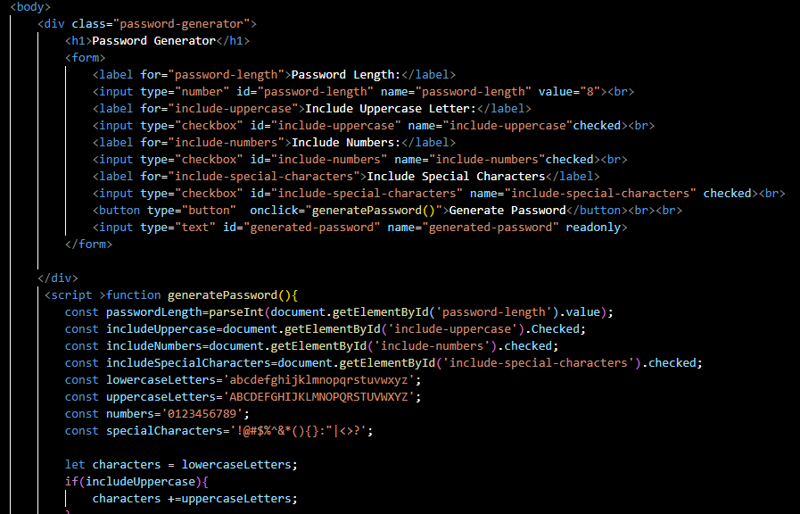
Fig4: password route map.
Fig5: password code

outcome
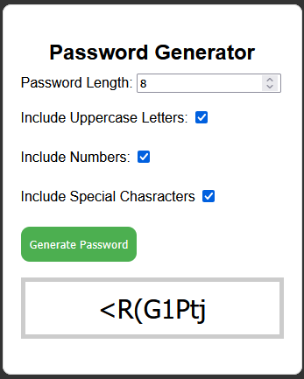

Fig6: password generator form.

2.2.4. Exploring the world of tech fields.
This field was presented using power point presentation on a slide.
2.2.4.1 Software development
Software Development involves designing, building, testing and maintaining software applications. These can range from mobile apps, games, and web applications to operating systems, enterprise software, and more.
Some areas of software development includes; mobile app development, web development, game development, cloud computing. All these apps development can be built using programming languages such as HTML, JAVA, JavaScript, Python, C++, C# and many others.
The core principles of software development are the foundation upon which the field is built, here are some key principles;
1. Separation of concern: breaking down the complex systems into smaller, independent components that are easier to manage and maintain.
2. Modularity: designing software systems as a collection of modular that can be easily reused and combined.
3. Abstraction: representing complex systems in a simplified way, focusing on essential features and hiding non-essential details.
4. Reusability: designing software components that can be reused in multiple contexts, reducing development time and increasing efficiency. And many others
Importance
1. Innovation: software development enables innovations in various industries, such as healthcare, finance, education, and more.
2. Economic Growth: the software industry is a significant contributor to the global economy. It creates jobs, generates revenue and stimulate economic growth.
- Problem-Solving: Software Development helps solve complex problems in various domains, such as climate change, healthcare and education. And many others.
2.2.4.2 Data science
Data Science is a field that combines statistics, computer science, and domain-specific knowledge from data. It’s a highly interdisciplinary field that has applications in various industries. Some of the key areas within Data Science include:

1. Machine Learning: developing algorithms and statistical models that enable computers to learn from data.
2. Data Visualization: using visual representations to communicate insights and patterns in data.
3. Data Mining: discovering patterns and relationships in large datasets. And many others.

The core principles of Data Science are the foundation upon which the field is built, here are some of the key principles:

1. Data-Driven Decision Making: using data to inform business decisions and drive outcomes.
2. Exploratory Data Analysis: exploring and understanding data to identify patterns, trends, and correlations.
3. Hypothesis-Driven Approach: formulating hypotheses and testing them using data to validate or invalidate assumptions.
4. Modeling and Prediction: using statistical and machine learning models to predict outcomes and forecast future events

Importance
The field of Data Science is incredibly important, here are some reasons why:

1. Informed Decision Making: Data Science enables organizations to make informed decisions by providing insights and patterns in data.
2. Business Growth and Optimization: Data Science helps businesses optimize operations, improve customer experiences, and increase revenue.
3. Competitive Advantage: Organizations that leverage Data Science gain a competitive advantage over those that don't.
4. Improved Healthcare: Data Science is used in healthcare to improve patient outcomes, develop personalized medicine, and optimize clinical workflows. And many others.

2.2.4.3 Cybersecurity
Cybersecurity is the practice of protecting computer systems, networks, and sensitive information from unauthorized access, use, disclosure, disruption, modification, or destruction. It's a critical field that's essential for protecting individuals, businesses, and governments from cyber threats. Some of the key areas within Cybersecurity include:

1. Network Security: protecting computer networks from unauthorized access, use, or disruption.
2. Application Security: protecting software applications from vulnerabilities and threats.
3. Data Security: protecting sensitive data from unauthorized access, use, or disclosure.
4. Cloud Security: protecting cloud-based systems and data from cyber threats.
5. Endpoint Security: protecting endpoint devices such as laptops, desktops, and mobile devices from cyber threats.
The core principles of Cybersecurity are the foundation upon which the field is built, here are some of the key principles:
1. Confidentiality: protecting sensitive information from unauthorized access or disclosure.
2. Integrity: ensuring that data is accurate, complete, and not modified without authorization.
3. Availability: ensuring that data and systems are accessible and usable when needed.
4. Authentication: verifying the identity of users, devices, and systems to ensure authorized access.
Importance
The field of Cybersecurity is incredibly important, here are some reasons why:
1. Protecting Sensitive Information: Cybersecurity helps protect sensitive information, such as personal data, financial information, and confidential business data.
2. Preventing Financial Loss: Cybersecurity helps prevent financial loss due to cyber attacks, such as ransomware, phishing, and other types of cybercrime.
3. Maintaining National Security: Cybersecurity is critical to maintaining national security, as cyber attacks can compromise sensitive government information and disrupt critical infrastructure.
2.2.4.4 IT and Networking
IT and Networking involves the design, implementation, and management of computer systems, networks, and infrastructure. It's a critical field that enables organizations to communicate, collaborate, and operate efficiently. Some of the key areas within IT and Networking include:
1. Network Administration: managing and maintaining computer networks, including local area networks (LANs), wide area networks (WANs), and the Internet.
2. System Administration: managing and maintaining computer systems, including hardware, software, and operating systems.
3. Cloud Computing: managing and maintaining cloud-based infrastructure, platforms, and applications.
4. Cybersecurity: protecting computer systems, networks, and data from cyber threats and vulnerabilities.
Some of the most in-demand IT and Networking roles include:

1. Network Engineer: designing, implementing, and managing computer networks.
2. System Administrator: managing and maintaining computer systems, including hardware, software, and operating systems.
3. Cloud Engineer: designing, implementing, and managing cloud-based infrastructure, platforms, and applications.
4. Cybersecurity Specialist: protecting computer systems, networks, and data from cyber threats and vulnerabilities.

The core principles of IT and Networking are the foundation upon which the field is built, here are some of the key principles:
1. Scalability: designing systems and networks that can scale to meet growing demands.
2. Reliability: ensuring that systems and networks are reliable and can withstand failures.
3. Security: protecting systems and networks from unauthorized access, use, disclosure, disruption, modification, or destruction.
4. Performance: optimizing systems and networks for maximum performance and efficiency.
5. Availability: ensuring that systems and networks are available and accessible when needed.
6. Maintainability: designing systems and networks that are easy to maintain, upgrade, and repair.

The field of IT and Networking is incredibly important,
here are some reasons why:
1. Enabling Communication: IT and Networking enable communication and collaboration across the globe, connecting people, businesses, and organizations.
2. Supporting Business Operations: IT and Networking are critical to the operation of businesses, providing the infrastructure and systems needed to manage, store, and process data.
3. Driving Innovation: IT and Networking drive innovation, enabling the development of new technologies, products, and services that transform industries and improve lives.
4. Protecting Data and Systems: IT and Networking professionals play a critical role in protecting data and systems from cyber threats, ensuring the confidentiality, integrity, and availability of sensitive information.
5. Improving Efficiency and Productivity: IT and Networking help organizations improve efficiency and productivity, automating processes, streamlining workflows, and providing real-time insights and analytics.
2.2.4.5 Artificial Intelligence (AI) and Robotics
Artificial Intelligence (AI) and Robotics involve the design, development, and deployment of intelligent systems that can think, learn, and act like humans. These systems can perform tasks that typically require human intelligence, such as visual perception, speech recognition, and decision-making.
Some of the key areas within AI and Robotics include:
- Machine Learning: developing algorithms and statistical models that enable machines to learn from data and improve their performance over time.
- Natural Language Processing: developing systems that can understand, interpret, and generate human language.
- Computer Vision: developing systems that can interpret and understand visual data from images and videos.
- Robotics: designing and developing robots that can perform tasks that typically require human intelligence and physical ability.

The core principles of Artificial Intelligence (AI) and Robotics are the foundation upon which the field is built, Here are some of the key principles:
1. Machine Learning: the ability of machines to learn from data and improve their performance over time.
2. Autonomy: the ability of machines to operate independently and make decisions without human intervention.
3. Intelligence: the ability of machines to think, reason, and solve problems like humans.
4. Adaptability: the ability of machines to adapt to changing environments and situations.
Importance
The field of Artificial Intelligence (AI) and Robotics is incredibly important. Here are some reasons why.
1. Improving Efficiency: AI and robotics can automate repetitive and mundane tasks, freeing up humans to focus on more creative and high-value work.
2. Enhancing Decision-Making: AI can analyze vast amounts of data and provide insights that humans might miss, leading to better decision-making.
3. Transforming Healthcare: AI and robotics are being used to develop new medical treatments, improve patient outcomes, and enhance the overall quality of healthcare.
4. Revolutionizing Transportation: AI and robotics are being used to develop self-driving cars, drones, and other vehicles that can improve safety, reduce traffic congestion, and enhance mobility.
5. Enhancing Customer Experience: AI-powered chatbots and virtual assistants are being used to provide personalized customer service, improve customer engagement, and enhance the overall customer experience.
6. Supporting Education: AI and robotics are being used to develop personalized learning platforms, improve student outcomes, and enhance the overall quality of education.
7. Improving Safety and Security: AI and robotics are being used to develop advanced security systems, improve emergency response times, and enhance overall safety and security.
2.2.4.6 UX/UI Design
UX/UI Design involves creating user-centered design solutions that provide a seamless and intuitive experience for users when interacting with digital products, such as websites, mobile apps, and software.
Some of the key areas within UX/UI Design include:
1. User Research: understanding user needs, behaviors, and motivations through research and analysis.
2. Wireframing and Prototyping: creating low-fidelity sketches and high-fidelity prototypes to visualize and test design concepts.
3. Visual Design: creating visually appealing and consistent design elements, such as typography, color schemes, and icons.
4. Interaction Design: designing interactive elements, such as buttons, forms, and navigation, to create a seamless user experience.
5. Usability Testing: testing design solutions with real users to identify areas for improvement
The core principles of UX/UI Design are the foundation upon which the field is built,
Here are some of the key principles:
1. User-Centered Design: designing with the user's needs, goals, and behaviors in mind.
2. Empathy: understanding and sharing the feelings of the user to create a more human-centered design.
3. Clarity: making the design clear, concise, and easy to understand.
4. Consistency: ensuring consistency in design elements, such as typography, color schemes, and icons.
5. Hierarchy: organizing design elements in a logical and intuitive way to guide the user's attention.
The field of UX/UI Design is incredibly important,
Here are some reasons why:
1. Improves User Experience: UX/UI Design helps create products that are intuitive, easy to use, and provide a seamless experience for users.
2. Drives Business Success: A well-designed product can increase user engagement, conversion rates, and ultimately, revenue.
3. Enhances Brand Reputation: A positive user experience can lead to increased brand loyalty, customer satisfaction, and advocacy.
4. Saves Time and Resources: By designing products that are intuitive and easy to use, UX/UI Design can help reduce support queries, returns, and other costs associated

2.2.4.7 chosen field of interest ( Cybersecurity)
Reasons for choosing this field to study
1. High demand: Cybersecurity is a rapidly growing field with a high demand for skilled professionals.
2. Job security: As technology advances, cybersecurity threats are becoming more sophisticated, making cybersecurity professionals essential to organizations.
3. Variety of roles: Cybersecurity encompasses a range of roles, from technical to managerial, so you can find a role that fits your skills and interests.
4. Constant learning: Cybersecurity is a constantly evolving field, with new threats and technologies emerging all the time, so I will have opportunities to learn and grow.
5. Impact: As a cybersecurity professional, I will have the opportunity to make a real impact by protecting individuals, organizations, and governments from cyber threats.
Roles/Specifications within this field
1. Security Analyst: Responsible for monitoring and analyzing security threats, as well as implementing security measures to prevent attacks.
2. Penetration Tester: Simulates cyber attacks on an organization's computer systems to test their defenses and identify vulnerabilities.
3. Incident Responder: Responds to and manages security incidents, such as data breaches or malware outbreaks.
4. Chief Information Security Officer (CISO): Oversees and implements an organization's overall security strategy.
5. Security Consultant: Provides security advice and guidance to organizations, helping them to improve their security posture.
6. Compliance Officer: Ensures that an organization is compliant with relevant security regulations and standards.
7. Digital Forensics Analyst: Analyzes digital evidence to investigate cyber crimes and security incidents.
8. Cloud Security Specialist: Focuses on securing cloud-based systems and data.
9. Network Security Engineer: Designs and implements secure network architectures and protocols.
10. Cybersecurity Architect: Designs and implements secure systems and architectures.
11. Security Operations Center (SOC) Analyst: Monitors and analyzes security-related data from various sources to identify potential security threats.
12. Threat Intelligence Analyst: Analyzes and interprets threat intelligence data to identify potential security threats.
These are just a few examples of the many different roles and specializations within the field of cybersecurity,
Each role requires a unique set of skills and knowledge, and there are many different paths you can take to pursue a career in cybersecurity.

2.3 Data Registration into Database (students registration form)
Data registration into database is done through xampp using languages such as apache, php and mysql. A group project whose objective was to share ideas and learn new languages such as php, apache, and mysql.
Mysql is used to create table for database registration in xampp. First the xampp is open to run apache and mysql
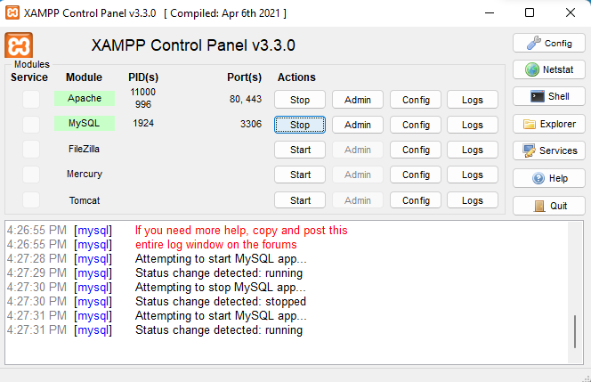

Fig7: xampp, running mysql and apache
A table of data is created by opening Admin.

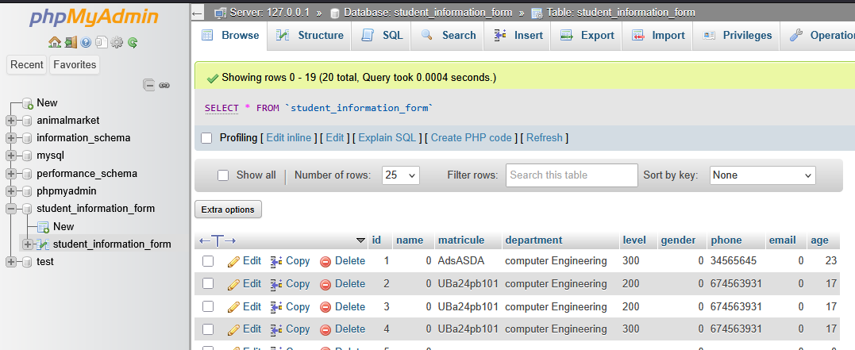
Fig8:database table.
The php language is used to write the code for the registration of data into the table.

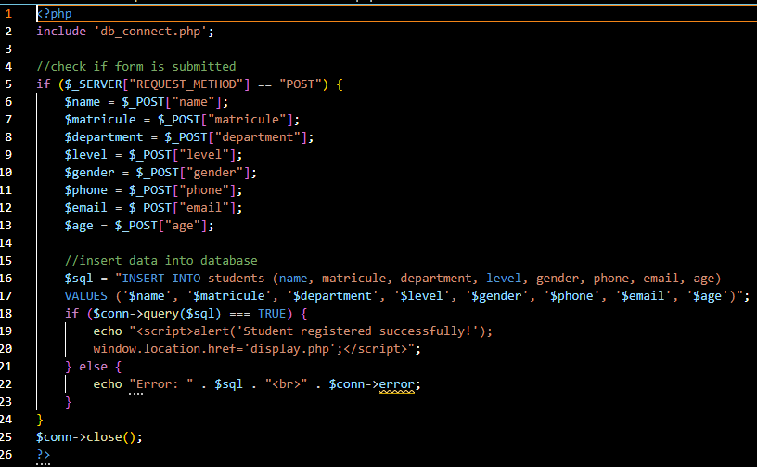
Fig9: php code for inputing data into table.
2.4 Using Ping and Traceroute (tracert) Commands to analyze Network Connectivity and Website Responsiveness.
1. ping: ping is used to check the availability of website and to check whether the website has a good connection with your machine, this is true if the website is responding to ping.
Steps to follow
- Open the command promt on your machine.
- Type in ping.(the required website) example, ping.youtube.com, and press the “enter” key
- Analyze your results and see if the website is available. A successful response will give the time for the ping message to reach the website and returns
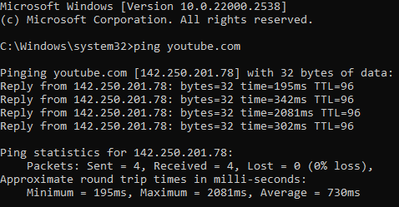
Fig10: ping result for youtube.com
2. Traceroute: traceroute is use to check the responsiveness of a website and to check any potential issues with the network connection. It gives the exact position of the fault in the network system.
Steps to follow
- Open the traceroute command promt
- Type in tracert.(required website) example, tracert.youtube.com and press the “enter” key
- Analyze the response.
Look at the response to see the network path taken to reach the website. The response will show the IP addresses of the routers and servers that the request passed through, along with the time it took for each hop.
Analyze the response times and network hops to identify any potential issues with the website's availability or responsiveness.
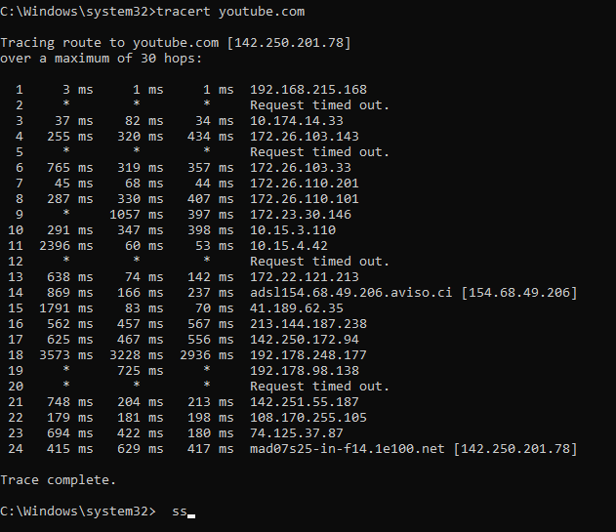
Fig11: tracert for youtube.com

2.5 PROBLEMS ENCOUNTERED DURING INTERNSHIP PERIOD
● Shortage of qualified staff: The few available workers are qualified but a single worker
performs many functions within the organization which could result in overload and
hence inefficiency. Most at times, I had to teach myself and even teach other students and
interns.
● Idleness: At times, no work or task is allocated to students and interns which make them
become idle
● The building accommodating the organization is small: This results in many different
activities being carried out in the same room which leads to distraction, errors, and
efficiency. Sometimes, I had to work with other students in the same room.
● Building location: The building is very close to the main road. There is a lot of noise
which hinders people from focusing on certain tasks. There is also a bakery nearby which
distracts people with the smell of bread.

2.6 PROPOSED SOLUTIONS TO THE PROBLEMS ENCOUNTERED
● Provide sub-task for interns to carry out on a daily basis to avoid them being idle
● Placing students and interns in different learning or working rooms
● Hiring more qualified staff who can carry out specific functions
● Removing anything that might cause distractions and taking noise reduction techniques
on the building or office.
CONCLUSION
This internship period is my first experience working in an institute. It has given me a better
understanding of software engineering and what it is all about. I have learned how to interact
with people in an organization and work with others as a team on projects and tasks.
RECOMMENDATIONS
I suggest that there should be a well-equipped workshop with tools for all the students who are to
be trained in either hardware or software and equally in all the other departments. There should
be a hall for cybercafé with enough computers to browse the internet and do research and many
other things that can be done on the internet.
BIBLIOGRAPHY

W3Schools. “JavaScript.” W3Schools, w3schools.com
Firebase, https://firebase.google.com/products-build
https://www.w3schools.com/js/js_output.asp
YouTube

